|  |  |  |  |  |  |  |  |  |  |
| --- | --- | --- | --- | --- | --- | --- | --- | --- | --- |
| SCHOOL OF COMPUTER SCIENCE AND ARTIFICIAL INTELLIGENCE | | | | | **DEPARTMENT OF COMPUTER SCIENCE ENGINEERING** | | | | |
| ProgramName:B. Tech | | | | Assignment Type: Lab | | | **AcademicYear:**2025-2026 | | |
| CourseCoordinatorName | | | | Venkataramana Veeramsetty | | | | | |
| Instructor(s)Name | | | | Dr. Mohammed Ali Shaik Dr. T Sampath Kumar Mr. S Naresh Kumar  Dr. V. Rajesh Dr. Brij Kishore  Dr Pramoda Patro Dr. Venkataramana  Dr. Ravi Chander Dr. Jagjeeth Singh | | | | | |
| CourseCode | | | 24CS002PC215 | CourseTitle | | AI Assisted Coding | | | |
| Year/Sem | | | II/I | Regulation | | R24 | | | |
| Date and Day of Assignment | | | Week2-Tuesday | Time(s) | |  | | | |
| Duration | | | 2 Hours | Applicableto Batches | | 24CSBTB01 To 24CSBTB39 | | | |
| AssignmentNumber:3.2(Present assignment number)/24(Total number of assignments) | | | | | | | | | |
|  | | | | | | | | | |
|  | Q.No. | Question | | | | | | ***Expected Time***  ***to complete*** |  |
|  | 1 | Lab 3: Prompt Engineering – Improving Prompts and Context Management Lab Objectives:  To understand how prompt structure and wording influence AI-generated code.  To explore how context (like comments and function names) helps AI generate relevant output. To evaluate the quality and accuracy of code based on prompt clarity.  To develop effective prompting strategies for AI-assisted programming.  Lab Outcomes (LOs):  After completing this lab, students will be able to:  Generate Python code using Google Gemini in Google Colab.  Analyze the effectiveness of code explanations and suggestions by Gemini. Set up and use Cursor AI for AI-powered coding assistance. | | | | | | 03.08.2025  EOD |  |

|  |  |  |
| --- | --- | --- |
|  | * Evaluate and refactor code using Cursor AI features. * Compare AI tool behavior and code quality across different platforms.   **Task Description#1**   * + Ask AI to write a function to calculate compound interest, starting with only the function name. Then add a docstring, then input-output example   **Expected Output#1**   * + Comparison of AI-generated code styles   **PROMPT1:**  Give a python code to calculate the compound interest using functions starting with only function name.    **PROMPT2:**  **write a python code to calculate compound interest using function name** |  |

|  |  |  |
| --- | --- | --- |
|  | **PROMPT3:**  **write a complex code to calculate the compound interest using functions in python.** |  |

|  |  |  |
| --- | --- | --- |
|  | **Task Description#2**   * Do math stuff, then refine it to: # Write a function to calculate average, median, and mode of a list of numbers.   **Expected Output#2**   * AI-generated function evolves from unclear to accurate multi-statistical operation. PROMPT 1:     PROMPT 2:  Write a function to calculate average, median, and mode of a list of numbers. |  |

|  |  |  |
| --- | --- | --- |
|  | PROMPT 3:  write a complex and simple python code to calculate the mean,median,mode for the list of numbers |  |

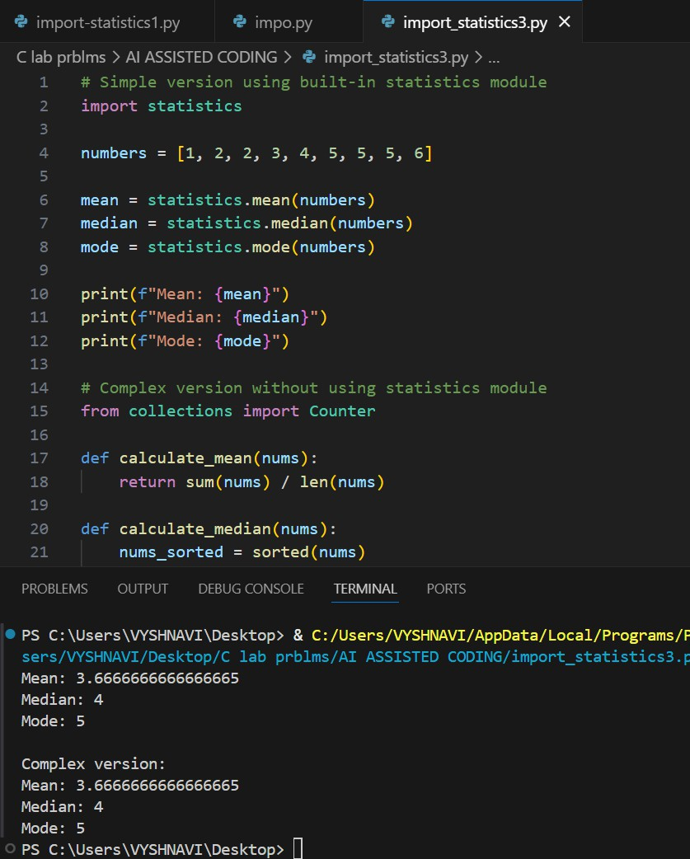

**Task Description#3**

* Provide multiple examples of input-output to the AI for convert_to_binary(num) function. Observe how AI uses few-shot prompting to generalize.

**Expected Output#3**

* Enhanced AI output with clearer prompts PROMPT 1:

"Can you convert 10 to binary?"

|  |  |  |
| --- | --- | --- |
|  | PROMPT 2:  write a python function code to convert numbers to binary |  |

|  |  |  |
| --- | --- | --- |
|  | PROMPT 3:  "I want to train an AI model using few-shot prompting to learn how to convert integers to binary strings |  |

|  |  |  |
| --- | --- | --- |
|  | **Task Description#4**   * Create an user interface for an hotel to generate bill based on customer requirements   **Expected Output#4**   * Consistent functions with shared logic PROMPT 1:   "Can you make a simple hotel bill generator?" |  |

|  |  |  |
| --- | --- | --- |
|  | PROMPT 2:  "I need a user interface for a hotel billing system that calculates charges based on customer preferences like room type and services used. Can you help?"    PROMPT 3:  "Design a responsive front-end interface for a hotel management system that generates itemized bills based on customer inputs such as room category, duration of stay, and optional services. Include modular components for discounts, taxes, and final billing |  |

|  |  |  |
| --- | --- | --- |
|  | summary."    **Task Description#5**   * Analyzing Prompt Specificity: Improving Temperature Conversion Function with Clear Instructions   **Expected Output#5**   * Code quality difference analysis for various prompts PROMPT 1:   write a code temperature converstion function with clear instruction by using python. |  |

|  |  |  |
| --- | --- | --- |
|  | PROMPT 2:  give a python code to convert the improving temperature conversion funtion with clear instruction.    PROMPT 3: to improve the temperature write a python code to create a temperatue conventor |  |

|  |  |  |  |  |
| --- | --- | --- | --- | --- |
|  | **Note: Report should be submitted a word document for all tasks in a single document with prompts, comments & code explanation, and output and if required, screenshots**  **Evaluation Criteria:** | | |  |
| **Criteria** | **Max Marks** |  |
| Task#1 | 0.5 |
| Task#2 | 0.5 |
| Task #3 | 0.5 |
| Task #4 | 0.5 |
| Task #5 | 0.5 |
| **Total** | **2.5 Marks** |
|  | | |